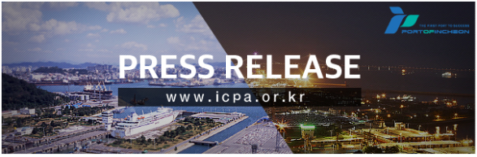
Excitement fills Incheon Port with Favorable news coming out ahead of the South and North Korea Summit Meeting
"Should be the hub of 'Triangular Logistics Network' among South and North Korea and China"

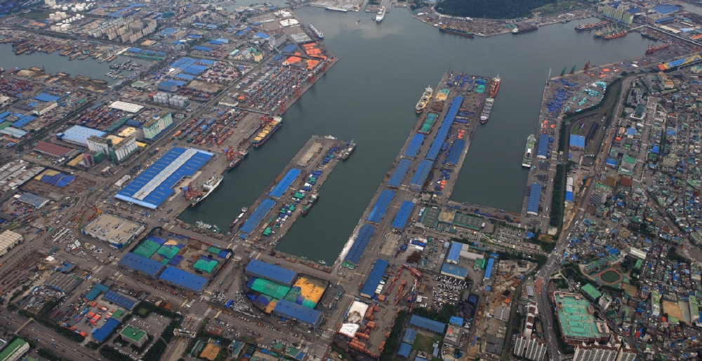
▲ Bird’s-eye-view of Inner Incheon Port, which was the center of the trading with North Korea in the past

○ Incheon Port is filled with excitement with the news of the 3rd South and North Korea Summit Meeting on the 18th in Pyeongyang. There is a growing anticipation of full scale commencement of economic cooperative projects between the South and the North with Incheon Port as a base. There are also opinions that Incheon Port should be the hub of a ‘Triangular Logistics Network’ between South and North Korea and China.

▲ Traffic of volume at Incheon Port will increase rapidly in the event of unification

○ The Incheon Port Authority (IPA), under the presumption of the unification of Korea and opening of the Korea-China sea route occurs between 2030 and 2040, the volume of cargo transportation will increase to 7 million TEU (1 TEU refers to cargo in a singly 6m container) and No. of international travelers passing through the Port to 4 million by 2050.

○ 7 million TEU is more than 2 times the volume that the Incheon Port achieved last year for the first time since its opening.

○ If South and North Korea is unified, Incheon Port can be compared at par with the leading international container ports of the world such as Laem Chabang Port in Thailand that achieved total volume of 7.2 million TEU last year.

○ On the other hand, if the division between the South and the North continues and the Korea-China sea route stays closed, the container volume and international passengers handled by the Incheon Port will remain at about 5.7 million TEU and 3 million people, respectively, by 2050.

○ If the South and the North unify, then IPA analyzes that Gaeseong and Haeju in the North will become the hinterland regions of Incheon Port, thereby enabling activation of the transshipment functions for import and export between Incheon Port and international trading ports of the Yellow Sea in the North (including Nampo, Haeju and Songlim Ports).

○ Ports of the Yellow Sea in the North has the disadvantages including shallow depth of the water and substantial difference between the rise and fall of tide, and freezing of Seohan Bay that extends from Nampo Port to Shineuiju during the winter seasons since 2009.

▲ Need to newly establish trading port between the South and the North including Haeju Port

○ IPA has been presenting the opinion that Haeju Port needs to be opened along with Nampo Port that traded with Incheon Port in the past. This is based on the advantages of being able to solving the problem of securing construction material through the use of sea sand excavated from the dredging of the sea floor in course of establishing sea route, which is a major part of modernization of Haeju Port, and further harmonizing the flow of logistics at the Gaesung Industrial Complex situated at the back of Haeju Port.

○ There also is an opinion that the logistics in the Yellow Sea regions need to be further activated through opening of the sea route that connects Shineuiju Port that accommodates the shipping needs of 3 special economic estates in North Korea and Incheon Port.

○ The Korea Maritime Institute (KMI) asserted in its report, which analyzed the trends under the title of ‘Need for cooperation between the South and the North for maritime fisheries utilizing the special economic estates in North Korea’, that, “although the region of Shineuiju is not included in the existing direct route between the South and the North at the moment, 3 special economic estates in the North is situated closely and it is capable of accommodating the cargoes coming out of the special economic estates in the Jagang-do.” KMI added that, “in particular, North Korea has plans to develop Shineuiju as the logistics hub of Northeast Asia,” and that, “there is a need for us to assertively review investment into maritime shipping and ports in Shineuiju.”

▲ Time to consider the triangular trading that links South and North Korea, and China.

○ There are opinions that ‘Triangular Logistics Network’ should be established amongst South and North Korea, and China with Incheon Port as the hub.

○ Jeong, Tae Won, professor of Logistics Department at Sungkyul University, forecasted at the seminar on the economic cooperation between the South and the North held at the main auditorium if IPA in Jung-gu, Incheon on June 21 this years that, “Incheon Port stands to be the biggest beneficiary in the event of activation of trading between the South and the North.”

○ Professor Jeong explained that, “if you examine the current status of trading of North Korea, it can be noticed that toll processing trading in which intermediary materials exported from China is reprocessed into completed products such as consumptive goods and exported back to China has expanded markedly. Moreover, he anticipated that, “there is a need to establish logistics network that connects 3 countries, namely, South and North Korea, and China that generates transshipment cargo volumes with Incheon Port as the hub by South Korea getting involved in this trading format. This triangular logistics network can be connected to the sea routes to the USA and Europe by creating new export items.”

○ He also added that, “direct route between Incheon Port, and Nampo and Haeju Ports, and we need to consider the establishment of logistics network to North Korea that links the Incheon Port and Incheon International Airport.” He proposed that, “there is a need to review establishment of joint logistics center for the South and the North in the hinterland logistics estate of Incheon New Port.”

▲ ‘Stumbling blocks’ in the economic cooperation between the South and the North, centered-around Incheon Port

○ In order for economic cooperation between the South and the North, centered-around Incheon Port to be realized, the economic sanctions on North Korea by the international society need to be lifted first. Unless these USA-led sanctions on the North are lifted, it is not possible to pursue trading between Incheon Port and the ports in the North.

○ Yoon, Yeong Chan, the senior secretary to the President on national communication, disclosed on the accompaniment by the businessmen for the aforementioned Summit Meeting that, “there clearly are limitations in the economic cooperation between the South and the North due to sanctions on the North,” and that, “this Summit Meeting will deal with the future possibilities rather than the domains that realistically feasible right away.”

○ There also are opinions that the government needs to provide assertive supports for the stabilization of the project for maritime shipment to the North by the private sector.

○ Choi, Jun Ho, a general manager at Sinokor Merchant Marine Co., Ltd. who was formerly the Manager of the North Korea Logistics Team of Kookyang Shipping Co., Ltd. that ran the regularly scheduled operation of ‘Trade Fortune’ along the Incheon~Nampo sea route from 2001 to 2011, stated that, “substantial investment is needed for trading with North Korea including cost of purchasing ships along with the issue of taking more than 10 years to just recover the investment.” He further added that, “support by the government is essential since it is a business project that imparts substantial risks that private sector companies to bear.”
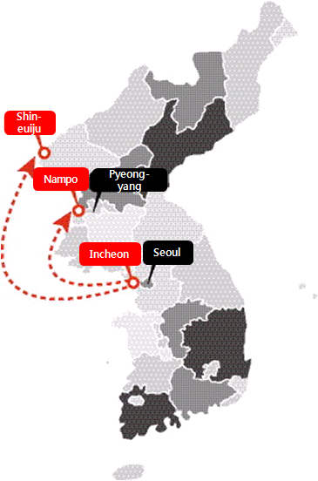

▲ Opinions on the opening of sea routes to Haeju and Shineuiju Ports as well as “lifting of economic sanctions on North Korea” and “government support” with the forecast that “Incheon Port will be the biggest beneficiary of trading between the South and the North”

